PROJECT TITLE: RETAIL SALES & PROFIT INTELLGENCE DASHBOARD
TOOL USED: POWER BI, EXCEL, DAX
DATASET : RELIANCE TRENDS DATASET

Project Summary
This project analyzes retail sales performance, profit margins, pricing behavior across multiple stores and product categories. The dashboard converts raw transactional data into actionable business insights by examining sales trends, customer behavior, brand performance, discount dynamics, and stock availability. The goal is to support data-driven decisions in merchandising, pricing and marketing.

Business Problem
Retail teams struggle to identify:
- Which products and brands drive revenue
- Which segments have the highest buying potential
- How discounts impact sales and profit
- Seasonal demand shifts across months
Data Preparation
The dataset was cleaned and enhance using Excel and Power BI. Key transformations included:
- Converting dates to proper Date type
- Creating Month, Year, Season columns
- Calculating Profit (Sales × 22%)
- Creating Discount% from sales
- Assigning Price Buckets
- Normalizing product names and brands (TRIM, PROPER)
- Creating measures for sales, profit, AOV, and brand share

Dashboard Explanation
1. 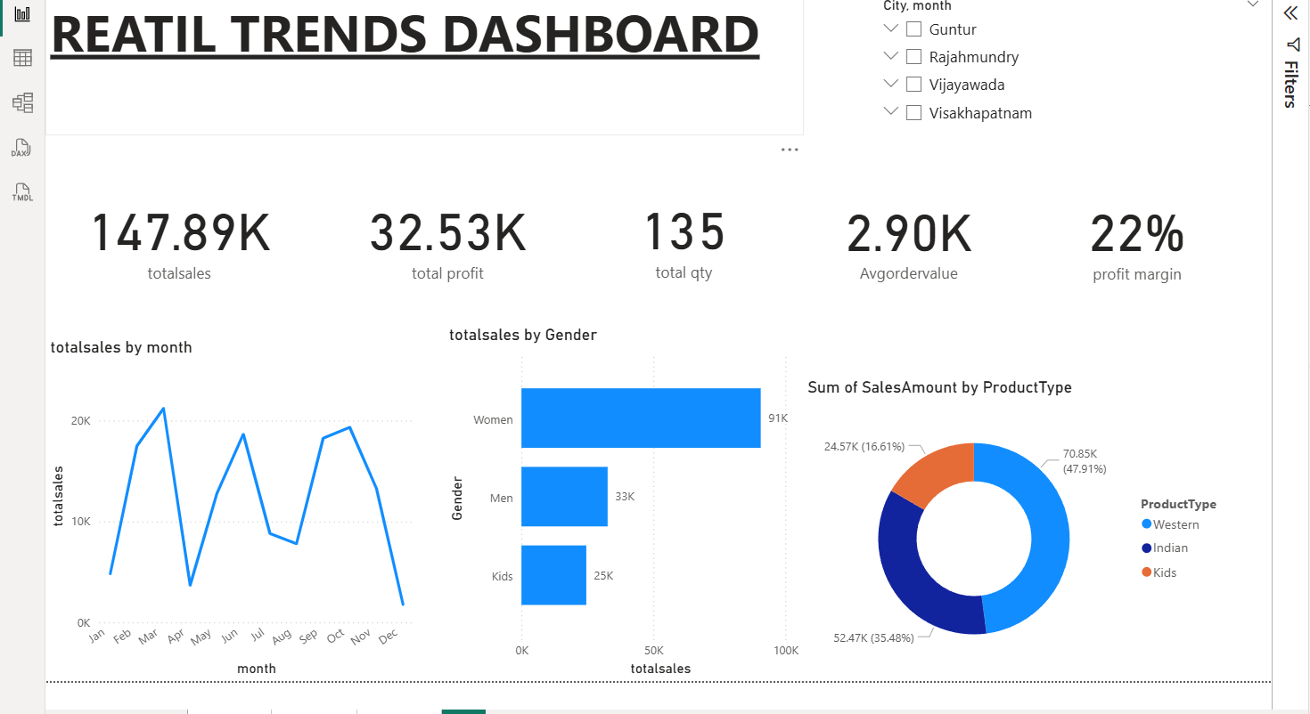
This page gives a quick overview of the overall business performance. It includes the main KPIs like Total Sales (147.89K), Total Profit (32.53K), Total Quantity Sold (135), Average Order Value (2.90K), and Profit Margin (22%).

- The month-wise trend shows sales ups and downs across the year.
- Gender analysis shows Women contribute the highest sales (91K), followed by Men and Kids.
- ProductType analysis shows Western wear as the top-selling segment.
- City and Month filters help quickly identify which city has the highest sales and how sales change month by month.
- This page helps understand overall performance, customer segments, and top categories at a glance.
2.
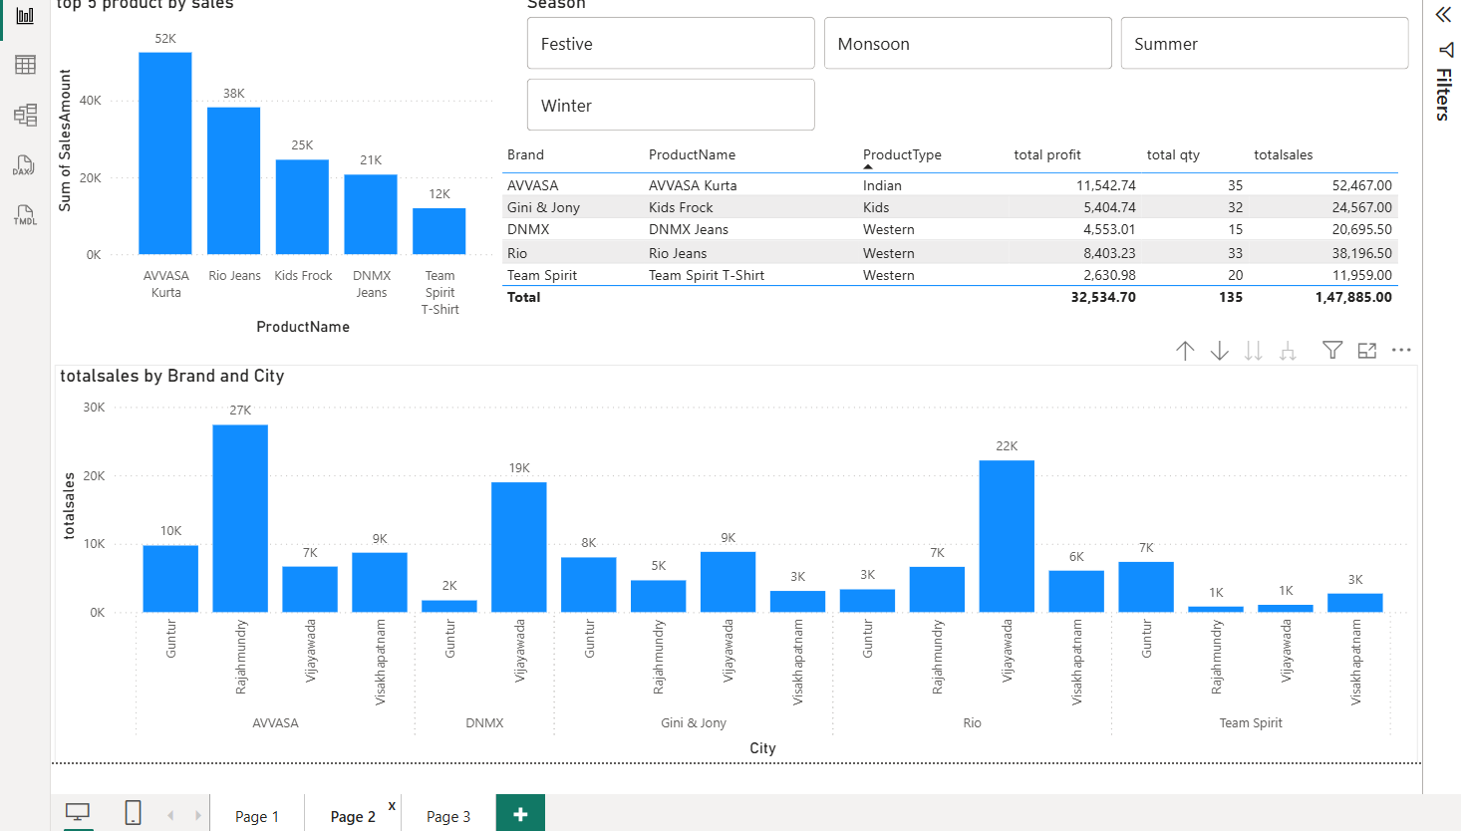
This page helps quickly understand which products and brands are performing well. The Top 5 Products chart shows that AVVASA Kurta, Rio Jeans, Kids Frock, DNMX Jeans, and Team Spirit T-Shirt generate the highest sales and profits.
- The Season slicer allows you to instantly check how product performance changes during Festive, Summer, Monsoon, or Winter. This makes it easy to see which products sell better in different seasons.
- The Brand vs City chart shows where each brand performs best. For example, AVVASA sells the most in Rajahmundry, while DNMX and Rio perform strongly in Vijayawada.
- Overall, this page helps identify top products, brand strengths, and best-performing cities in a very clear and simple way.
3.)
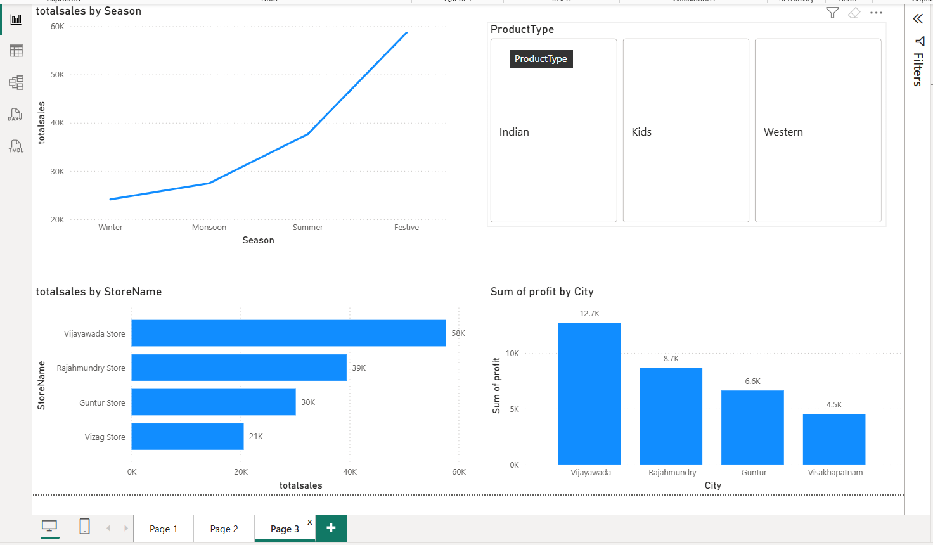
This page shows how sales change across different seasons and locations.
The Season chart clearly shows that sales keep increasing from Winter → Monsoon → Summer, and reach the highest during the Festive season, which means customers buy more during festival months.
- The ProductType buttons (Indian, Kids, Western) help quickly filter the visuals and check how each category performs across seasons and stores.
- The Store-wise sales chart shows that Vijayawada Store has the highest sales, followed by Rajahmundry, Guntur, and Vizag.
- The Profit by City chart helps understand which city is most profitable. Vijayawada again leads with the highest profit, followed by Rajahmundry.
- Overall, this page helps understand seasonal trends, store performance, and city-level profit in one place.

Key Insights
- Festive season shows the highest sales, confirming strong festival demand.
- AVVASA Kurta, Rio Jeans, Kids Frock, and DNMX Jeans are the top-selling products.
- Women contribute the most sales, making them the key customer segment.
- Vijayawada Store leads in both sales and profit, followed by Rajahmundry.
- Western wear is the top-selling product type, ahead of Indian and Kidswear.
- Brand-wise performance changes by city, with AVVASA strong in Rajahmundry and DNMX strong in Vijayawada.

Recommendations
- Increase stock and marketing focus during the Festive season, where sales peak the highest.
- Allocate more inventory of top-selling products like AVVASA Kurta, Rio Jeans, Kids Frock, and DNMX Jeans.
- Strengthen stock levels in Vijayawada and Rajahmundry, since these cities generate the highest sales and profit.
- Prioritize Women’s category, as it contributes the largest share of revenue.
- Expand Western wear collection as it is the highest performing product type.

Final conclusion
This dashboard clearly shows key trends in sales, seasons, cities, and products, helping identify what sells best, when demand peaks, and which stores perform strongest. It supports smarter decisions in inventory, product planning, and seasonal sales strategy.

